SPRT®

POS Thermal Receipt Printer

（SP-POS890）

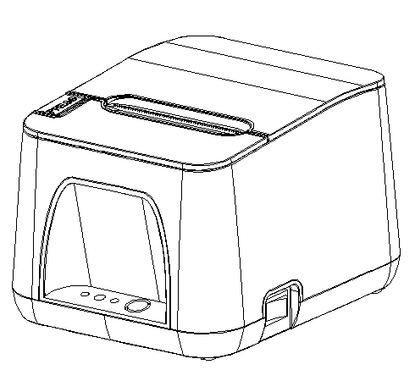

User’s Manual
（Ver 1.09）

Beijing Spirit Technology Development Co.,Ltd.
www.sprt-printer.com

Content

Introduction 1
Chapter 1 Feature and Performance 1
1.1 Print Performance 1
1.2 Print Paper 2
1.3 Print Font 2
1.4 Interface 2
1.5 Print Control Commands 3
1.6 Power Supply 3
1.7 Operation Environment 3
1.8 Outline Dimension 3
1.9 Model classification 3
Chapter 2 Operation Specification 4
2.1 Printer Appearance 4
2.2 Paper Installation 5
2.2.1 Paper Loading 5
2.2.2 Solution to Paper Jam 6
2.3 Interface 6
2.3.1 Ethernet Interface 6
2.3.2 USB Interface 7
2.3.3 Cash Drawer Interface 7
2.3.4 Power Connection 8
2.4 Buttons and Indicators 9
2.5 Power on status 11
2.6 Self-test 11
2.7 Hexadecimal Printing 12
2.8 Parameter Setting 13
2.9 Enter the program upgrade mode 14
2.10 Mode swift(Only for two-color printing model of SP-POS890E Plus)...........................................14
Appendix A 15

Introduction
POS890 printer is a new type line thermal printer, it features in fast speed print, low print noise, high reliability, perfect print quality and ribbon needless, avoiding the vexation of regular maintenance.

POS890 printer: small in outline dimension, simple operation, and extensive application, especially suitable for commercial cash register, PC-POS, bank POS and all kinds of receipts print.

Warning
This is a class A product. In a domestic environment this product
may cause radio interference in which case the user may be
required to take adequate measures.

Chapter 1 Feature and Performance

1.1 Print Performance
● Print method: direct thermal
● Print paper width: 79.5±0.5mm
● Print density: 8 dots/mm, 576 dots/line
● Print speed: max 250mm/s
● Reliability
- Life of the normal receipt Print head : 150km
Life of the model of SP-POS890E Plus:45km (according to the data of two-color printing printer)
Using condition:
＊Print 12 × 24 ASCII characters, print 50 lines each time, intermittent print repeatedly
＊Use specified thermal paper
(2) Cutter life: 1500,000 cuts
● Valid print width: 72mm
●Continuous Printing: When using the two-color printing function of the SP-POS890E Plus model, the maximum continuous printing length does not exceed 1 meter.

1.2 Print Paper
● Thermal paper roll model: TF50KS－E (Japan paper co.ltd)
AF50KS-E (JUJO THERMAL)
● Thermal paper roll: Paper Type－－Thermal Paper 79.5±0.5mm xф80mm（max）
Inner Diameter－－－13mm (min.)
Thickness －－－ 0.06mm～0.08mm
●Two-color printing: Paper roll of RM80*40 is needed when using the machine for two-color printing

1.3 Print Font
● ANK Character Set
12×24 dots,1.5（W）×3.00（H）mm
● GB GB2312-80(Chinese):
24×24 dots,3.00（W）×3.00（H）mm.

1.4 Interface
● Ethernet Interface: Normal Ethernet interface.
● USB Interface:USB interface
● Cash Drawer Control
DC24V, 1A, 6-pin RJ-11 socket.

1.5 Print Control Commands
● Character print commands: support double-width, double height print of ANK characters, user-defined characters and Chinese characters, the character line spacing is adjustable.
● Graphics print commands: support the print of bit-map graphics and download bit-map graphics with different density
●GS barcode print commands:
support UPC-A，UPC-E，EAN-13，EAN-8，CODE39，ITF25，CODEBAR，CODE93，CODE128,PDF417,QR code，DATA Matrix code print.
●Two-color printing commands: SP-POS890E Plus printers can support two-color printing, including the print font and raster bitmap.

1.6 Power Supply
● DC24V±10％, 2A, A-1009-3P power socket

1.7 Operation Environment
● Operation temperature: 0～50℃; Relative humidity: 10～80％
● Storage temperature: -20～60℃; Relative humidity: 10～90℃

1.8 Outline Dimension

●185(L)mm×150(W) mm×123 (H)mm
Model | Interface | Remark
POS890E | Ethernet Interface, USB Interface
POS890US | RS－232C Serial Interface, USB Interface
SP-POS890EBTWn | Ethernet Interface, USB&Bluetooth interface 4.0, WIFI 2.4G/5G interface
SP-POS890E Plus | Ethernet Interface, USB Interface | Support two-color printing

1.9 Model classification

Chapter 2 Operation Specification

2.1 Printer Appearance
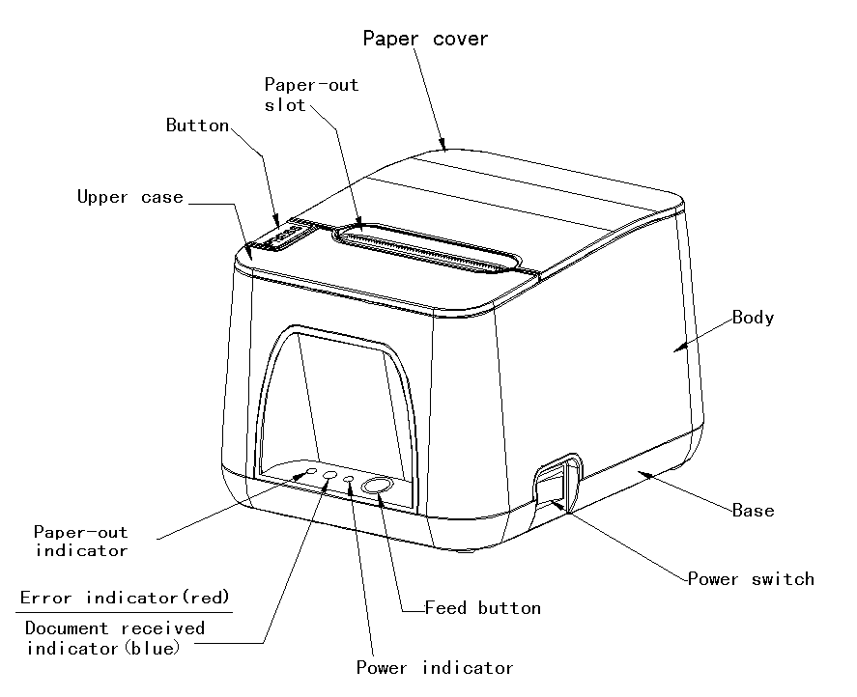

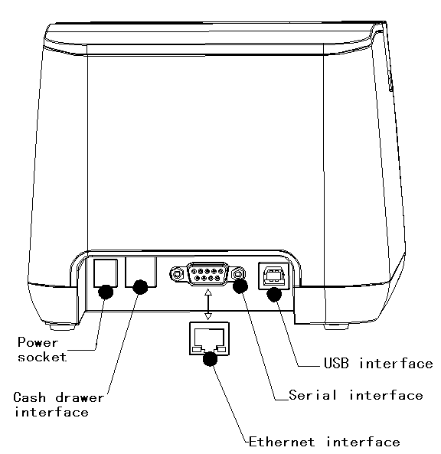

2.2 Paper Installation

2.2.1 Paper Loading
POS890 adopts 79.5mm±0.5mm width thermal paper roll.
Steps of Loading Thermal Paper are as below:
Hold down the upper cover button on the left side, open the movable upper cover, draw a certain length of the paper roll, put the paper end on the print head, close the upper cover and press it downwards lightly.
！Caution!

1. Pay attention to the direction of loading paper, make the printing surface face to the print head.
2. Please don’t feed or draw the paper forwards or backwards with hands.
3. Keep clean of the print head, avoid to influence the printing quality.

2.2.2 Solution to Paper Jam
If cutter jam, turn off the power, and turn on again, the cutter will be back to original position. If paper jam, open the paper strage cover, and take out the paper. If the cutter can not be back to the original position, open the cover of it, and turn the white plastic gear by the direction suggestive on the cutter by hand to make the cutter be back to the original position.

If cutter jam, but hope no loss of data in printer, don’t turn off the power. Get the cutter back to the original position by the above mentioned method by hand. Then open the paper cover and take out the paper, close the paper cover. The printer will recover automatically from Cutting Error.

2.3 Interface

2.3.1 Ethernet Interface

The model with Ethernet interface use RJ45 Network socket. The appearance is as Fig.2-2 shows:

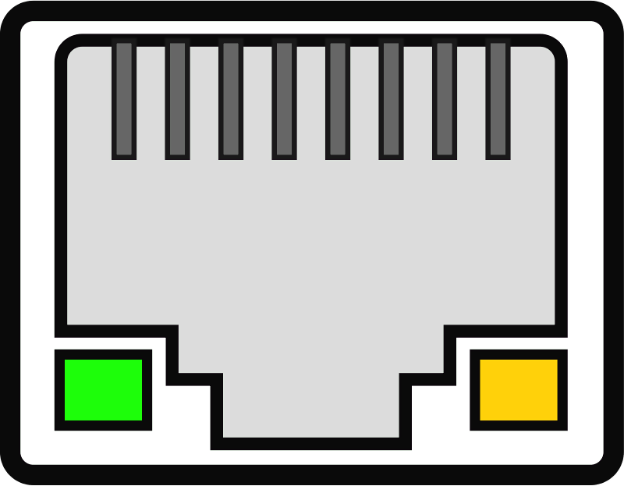
Fig.2-2 Ethernet interface

2.3.2 USB Interface
The standard accessories of POS890 printer includes a Mini USB cable which connects printer and main device. The USB type belongs to the slave device type(DEVICE). Pins description of Mini-USB as Fig.2-3 below:
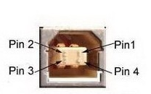
Fig.2-3 USB interface
Pin | Function | Notes
1 | V Bus | Power +5V
2 | Data- | Data-
3 | Data+ | Data-
4 | GND | Ground

2.3.3 Cash Drawer Interface
The cash drawer interface of POS890 adopts RJ-11 6-pin socket, as Fig.2-5 shows:

Fig.2-4 Cash Drawer Interface

The pin assignment is as below:

Pin No. | Signal | Direction
1 | Chassis Ground | ——
2 | Cash drawer driver signal 1 | Out
3 | Cash drawer on/off status signal | In
4 | +24VDC | ——
5 | Cash drawer driver signal 2 | Out
6 | Signal ground | ——

2.3.4 Power Connection
POS890 uses the external power supply adopter as 24V±10％,2A,
power socket is A-1009-3P model, as Fig. 2-5 shows:



The pin assignment is as below:
Pin No. | Signal
1 | +24VDC
2 | Ground
3 | NC

Fig.2-5 Definition of power socket and pin

2.4 Buttons and Indicators
There is one button and two inner buzzers(a bigger on and a smaller one) and three indicators on POS890 printer.
【FEED】is paper feeding button, the function of its enabling or disabling the button on/off can be set by print command, when the button is enabled, press 【FEED】 button, then the paper presenting driver starts up and paper fed into the printer; release【FEED】 button, paper feeding stops.
The smaller buzzer indicates the error status type, which can be set to enabling error alarm or disabling by parameter setting. Error status type is the same as error indicator.
The large buzzer is used to indicate a detection of printing. It can be set by the parameter settings to detection reminder function on / off.
The green POWER indicator is the power indicator. The POWER indicator lights, it indicate that the printer is turned on.
The red indicator is the paper status indicator. The indicator light indicates that the printer is out of paper.
Red/Blue indicator is ERROR/ALARM indicator, the red indicator is dark when printer work normally; and alarm abnormal status of printer while it flashes. When it flashes for a long time, it means paper case opened in the printing process. The blue indicator flashes reminds that printer has received document.
When the document received indicator flash, bigger buzzer ring for three times, it reminds that printer has received document.
When the error indicator flash and smaller buzzer ring, it means there is an error in the printer.
According to the different flicker type, the different error types are as below:
1. Non-recoverable error, the times of indicator flickering and buzzer sounding mean the error type, then persistent lighting.
2. Recoverable error, the times of indicator flickering and buzzer sounding mean the error type, then persistent indicator-off.
3. Auto-recoverable error, the indicator flickers and the buzzer sounds persistently.
4. Paper out, PAPER OUT indicator lights and the buzzer sounds persistently. When the paper case cover is open, whether the paper is out or not will not be tested, but just testing whether there is paper in printer.
The details are as below:
①.. Non-recoverable error, the indicator flickers several times, then persistent lighting. The times of flickering means the error type,
ERROR Type | ERROR Description | ERROR Indicator Flickering Type
Non-recoverable error | LED Flikers once:Internal memory reading and writing error
Non-recoverable error | LED Flikers twice:over-voltage
Non-recoverable error | LED Flikers three times:under-voltage
Non-recoverable error | LED Flikers four times: CPU execution error (wrong address) | 
Non-recoverable error | LED Flikers five times: UIB error
Non-recoverable error | LED Flikers six times: FLASH writing error
Non-recoverable error | LED Flikers seven times: parameter writing error
Non-recoverable error | LED Flikers eight times: Temperature testing circuit error | 

②. Recoverable error, indicator flickers constantly, then persistent off for one period.
ERROR Type | ERROR Description | ERROR Indicator Flickering Type
Recoverable error | LED Flikers once:Cutter position error

③. Auto-recoverable error, indicator flickers constantly, including printing head over-heat error and upper case cover opening error during printing.

ERROR Type | ERROR Description | ERROR Indicator Flickering Type
Auto-recoverable error | LED Flickers constantly: printing head over-heat; upper case cover opening error during printing

2.5 Power on status

Paper cover close when power off. Press the power button, the error indicator and paper out indicator flash twice alternately and out, then printer will be on the normal working mode.

2.6 Self-test
The self-test will check the condition of printer, if the printer prints out the self-test receipt correctly, it means the printer works normally, except interface with host. Otherwise it needs to repair. The self-test will print out the name of manufacturer, printer type, interface type and printer defaulted parameter, 96 characters in ASCII and defaulted Code page content(the language is English) or the name of Chinese characters library(if the language is Chinese) and Bar code type.

Way of self-test: hold down【FEED】button and turn on the power, self-test begins automatically at this moment.as Fig.2-6 shows
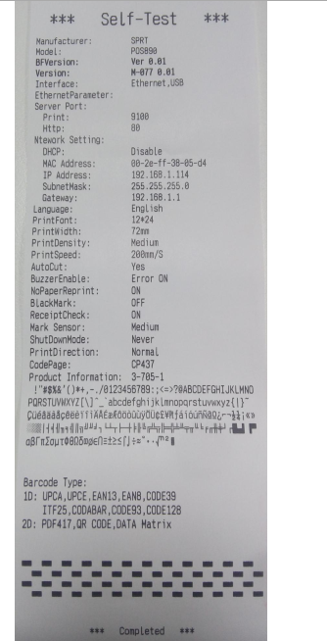
Fig.2-6

2.7 Hexadecimal Printing
Turn on the printer according to the step below, it will enter the mode of Hexadecimal Printing
1.Open the cover;
2.Hold down【FEED】button,and connect with power;
3.Close the cover, the printer will print out 3 lines as below:
Hexadecimal Dump
To terminate hexadecimal dump,
Press FEED button three times.
This means the printer has entered hexadecimal printing mode, and under this mode, all of the input will be printed out as hexadecimal number, feed one line with single-click of “FEED” button, after 3 times, it will print out “*** Completed ***”, and exit hexadecimal printing mode.

2.8 Parameter Setting

This function is for the setting of printer parameters.

Steps for setting parameters:

When printer power is off, open paper case cover firstly. Hold the【FEED】button, then switch on the printer and release the【FEED】when the status indicator and paper-out indicator flash alternately. Then press the 【FEED】twice and close the paper cover, printer enter the setting mode and print out the first set parameter and its default value. The details method of setting parameter can refer to Appendix A.

Steps for exiting of parameter setup:
Open paper case cover and press the【FEED】 button; then close paper case cover and release the 【FEED】 button. The printer will save the setup of parameters, exit setting mode and enter the normal working mode.
The data will not be saved if turn off the printer directly.

2.9 Enter the program upgrade mode

When printer is power off,open paper case cover. Hold the【FEED】button, then switch on the printer and release the【FEED】when the status indicator and paper-out indicator flash alternately. Then press the 【FEED】for five times and close the paper cover, printer enter the program upgrade mode. At this time, the status indicator flash once a second.

Quick enter method:
Open the paper case cover firstly when printer is power off. Hold the 【FEED】button and switch on the printer, then release the 【FEED】button quickly, then printer enter the program upgrade mode. At this time, the status indicator flash once a second.

Notice:
When printer enter the program upgrade mode, the paper-out indicator flash means the interface can’t be upgraded, only serial interface and USB interface are supported online program upgrading at the moment.

2.10 Mode swift(Only for two-color printing model of SP-POS890E Plus)
When the machine is turned off, open the [Paper Bin Cover], press and hold the [FEED] key, and then turn on the power switch, wait for more than 2 seconds or more before releasing the [FEED] key after the completion of the alternating blinking of the indicator lamps, and then close the [Paper Bin Cover], and the mode switching is completed.

Appendix A
This appendix is the method to set the printer parameter according to button operation.

Setting introduction: Press【Paper cover】button to choose setting,when press it once , the set become the next one and it will print the present set value; use【FEED】button to set the set value, when press it once , the set become the next one and it will print the present set value.

General Setting:
Print speed

Paper cover Paper cover aper cover paper cover
Baudratee

Print density

Font

Language

Paper cover paper cover paper cover paper cover
Buzzer

Paper-out reprint

Black mark

Baud rate:
FEED FEED FEED
9600

57600

38400

19200

FEED FEED
FEED FEED FEED
4800

115200

1200

2400

Language:
FEED FEED
China
English

China-BIG5

FEED

Font:
FEED
12×24

9×17

FEED

Print density:
FEED FEED
MEDIUM

LOW

HIGH

FEED

Print speed:
FEED FEED FEED
220mm/s

150mm/s
China
250mm/s
Eenglish
200mm/s
China

FEED

Buzzer:
FEED FEED FEED
OFF

Cut ON

Error ON

ALL ON

FEED

Paper-out reprint:
：
FEED
OFF

ON

FEED

Black mark mode:：
FEED
close

open

FEED

